**QUESTION 1**

Accuracy of fused majority voting classifier with Decision tree, Gaussian Naïve bayes, and Logistic Regression.

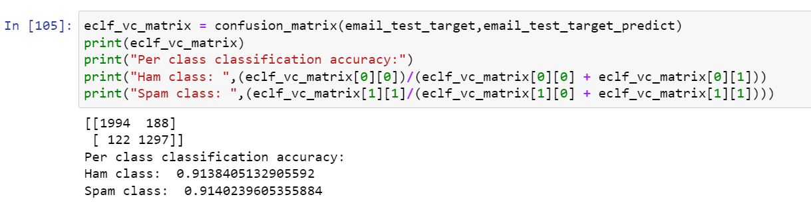



Accuracy of AdaBoost ensemble with Decision tree as base learner

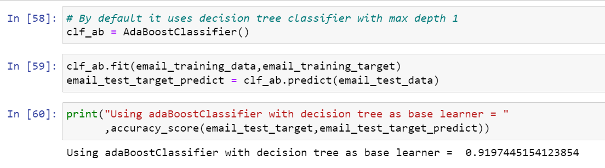

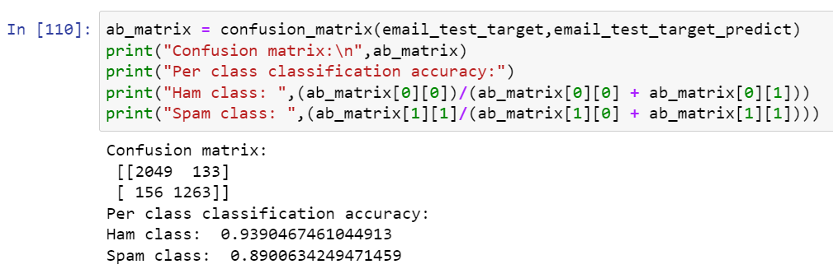

The AdaBoost ensemble with Decision Tree classifier has slightly high classification accuracy which is 91.97 percent compared to fused classifier which is 91.39 percent and if we compare the per class classification accuracy of AdaBoost ensemble learning then it is 93.90 percent but fused classifier has the accuracy of only 91.42 percent. Moreover, we can see that fused classifier is good in classifying wrong class compared to AdaBoost classifier and if see difference between two accuracies are almost 2 percent for spam class.

**QUESTION 2**

Accuracy of Random Forest Classifier with 1000 base learner.

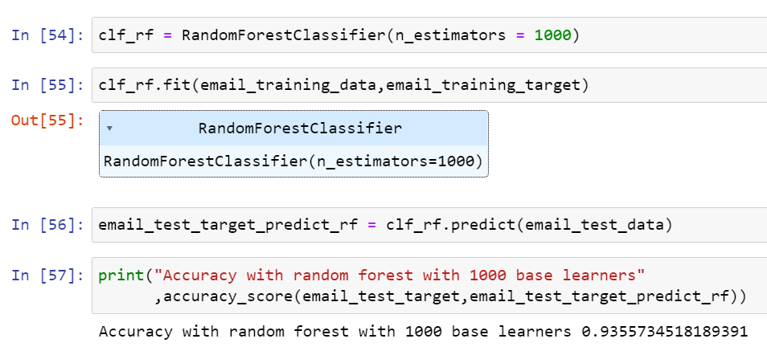

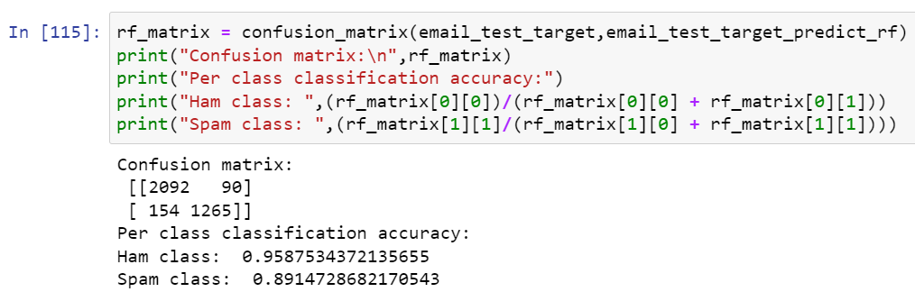

The Random Forest Classifier with 1000 base learners has accuracy of 93.56 percent while fused classifier has accuracy of 91.39 and if we compare the per class classification accuracy then we can observe that Random Forest Classifier has higher true positive rate compared to fused classifier with the difference of 4% but it has less accuracy in predicting spam class which is just 89 percent.

**QUESTION 3**

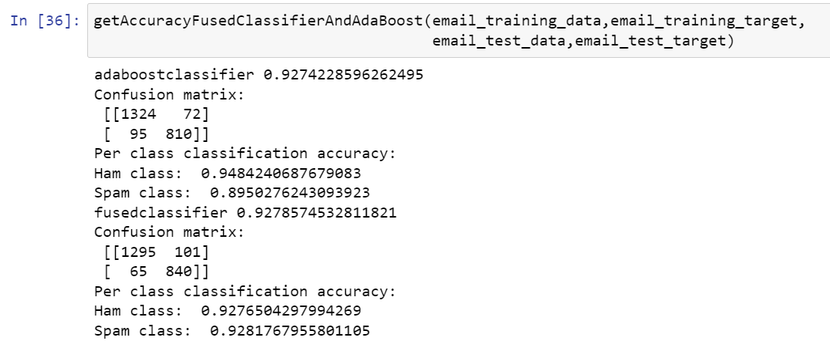

If we train AdaBoost classifier and majority voting fused classifier with 50% training data and 50% for testing then the classification accuracy has no major difference but AdaBoost has slightly higher per class classification accuracy for classifying the ham class which is 94% but it we see majority voting then it is 92%.

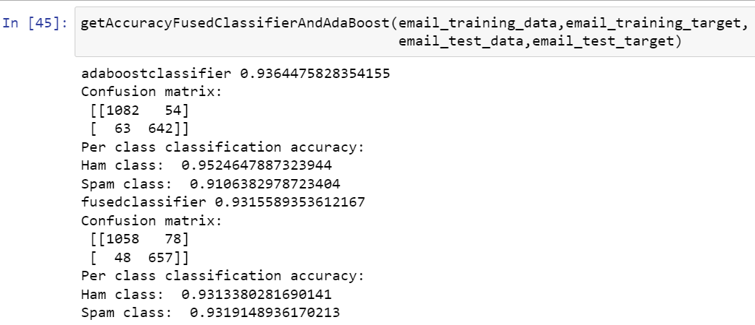

If we use 60%-40% train-test ratio then we can observe that overall classification accuracy of the both the classifier has increased by almost 1% and it is the same case with per class classification accuracy where we can observe the same increase.

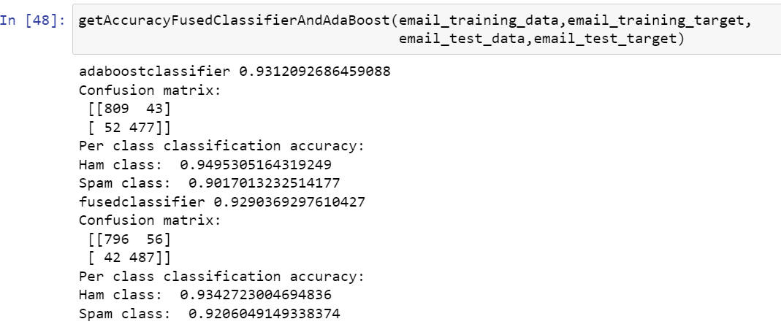

If we use 70%-30% train-test ratio then we can observe that accuracies have decrease compared to 60%-40% by 1% and if compare the per class classification accuracy then we can observe that the difference between to classifiers per class classification accuracy has decreased.

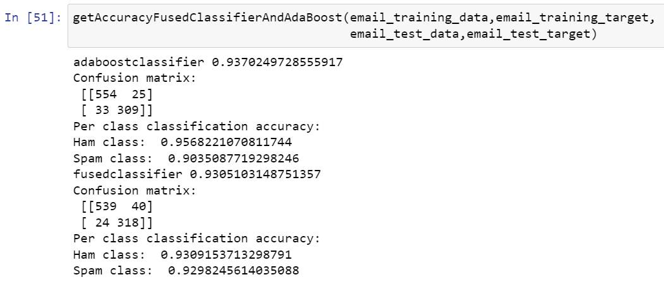

If we use 80%-20% train-test ratio then we can observe that there is not much difference between accuracies of two classifiers but we can see that the accuracies overall have increased by 0.7%.

In summary, we can observe that if we use 60%-40% train-test split than we would get the best accuracy for both the classifier which are majority voting which fused with Decision Tree, Naïve Bayes and Logistic regression and AdaBoost Ensemble classifier. We can also achieve higher per class classification accuracy in 60%-40% train-test split.